SHOPNEST POWERBI CAPSTONE PROJECT

(By-Satya Prakash Pradhan)

Project**:**

ShopNest is the premier department store in Portugal's e-commerce marketplace, serving as a vital bridge between small businesses across the country and online sales channels. By offering a single point of contact, ShopNest simplifies the selling process for merchants, enabling them to showcase and sell their products through the ShopNest Store. With the support of ShopNest’s logistics partners, products are shipped directly to customers, ensuring a seamless experience. The provided data consists of real commercial information that has been anonymized for privacy.

Tasks to do**:**

Design a comprehensive Power BI dashboard to address key business analytics for a retail dataset. The following analytical questions should be answered through your dashboard:

1. Identify the rating distribution in the Shop_Nest dataset, showcasing ratings categorized as Excellent, Very Good, Good, Bad, and Very Bad, along with corresponding orders.
2. What are the top 10 and bottom 18 most popular product categories in the ShopNest dataset? Please list them based on the number of orders.
3. List the total number of active sellers by yearly and monthly.
4. Which payment methods are most commonly used by ShopNest customers.
5. Identify the product category. wise profit margin using the formula

Hint: (Payment value -price + Freight_value)/payment_value*100 (Rounded to two decimal points).

1. Determine the monthly payments made by customers using credit cards.
2. Identify sellers categorized by city, excluding cities starting with the letters S and B.
3. Create a dynamic visual that compares the number of delayed orders to the number of orders received earlier for each month. Utilize the drill through the cross-report feature to provide a detailed analysis of late and on-time deliveries.

# TASK – 1

Question Statement:

Identify the rating distribution in the Shop_Nest dataset, showcasing ratings categorized as Excellent, Very Good, Good, Bad, and Very Bad, along with corresponding orders.

Visualization:

The The bar chart below presents the distribution of ratings in the Shop_Nest dataset, classified into five categories: Excellent, Very Good, Good, Bad, and Very Bad. The length of each bar represents the number of orders associated with each rating category.

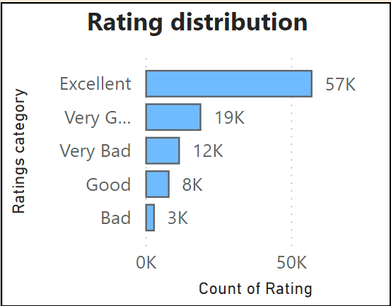

*Image* *1.* *Rating* *distribution*

Explanation:

* The majority of orders received an "Excellent" rating, totaling 57,420, highlighting a high level of customer satisfaction.
* " Very Good" ratings account for approximately 19,200 orders, reflecting positive customer feedback.
* The "Very Bad" rating was assigned to 11,858 orders. While this represents a small portion of total orders, it highlights an important area for improvement.
* The "Good" and "Bad" ratings correspond to approximately 8,000 and 3,000 orders, respectively.

This This distribution indicates that most customers had a positive experience with ShopNest, as reflected in the high number of positive ratings. However, the “Very Bad” rating stands out as a significant outlier that requires attention, as even a minor negative experience can impact the overall customer journey.

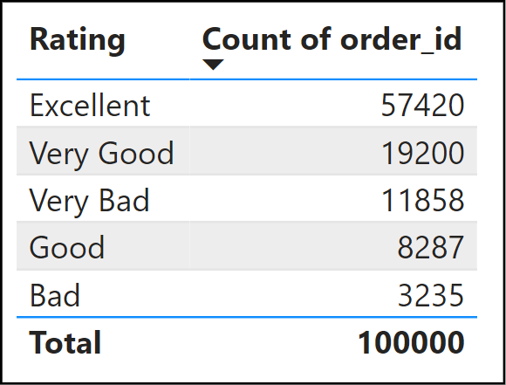

*Table* *1.* *Ratings* *table*

# TASK – 2

Question Statement:

What are the top 10 and bottom 18 most popular product categories in the ShopNest dataset? Please list them based on the number of orders.

Visualization:

The bar charts below depict the distribution of the Top 10 and Bottom 18 product categories in the Shop_Nest dataset, based on the number of orders. The length of each bar represents the total orders within each category. The first chart showcases the Top 10 product categories with the highest order volumes, while the second chart highlights the Bottom 18 categories with the lowest order counts.

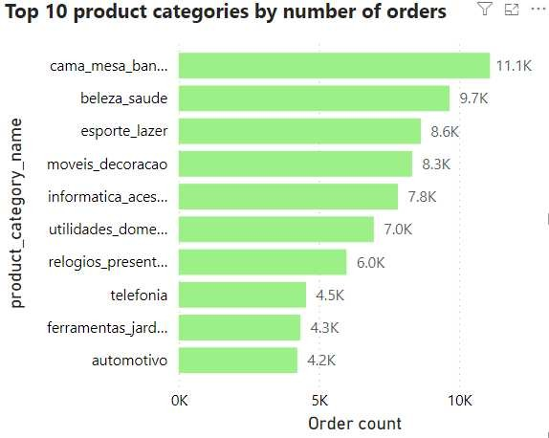

*Image* *2.* *Top* *10* *product* *category* *distribution*

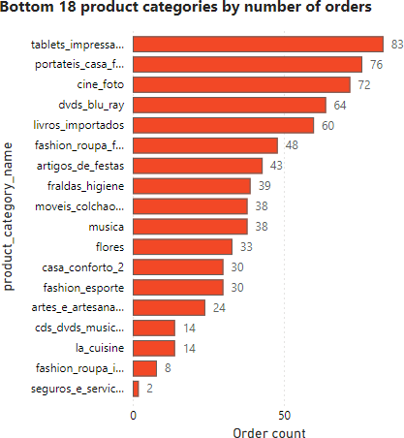

*Image* *3.* *Bottom* *18* *product* *category* *distribution*

Explanation:

* The bar chart and table data highlight the top 10 product categories based on order count. The "Bed, Bath, Table" category leads with approximately 11,115 orders. This suggests a high demand for home-related products.
* This is followed by the "Health & Beauty" category, which has 9,670 orders, reflecting a strong interest in personal care products.
* The "sports, leisure" category also shows 8,641 orders showing costumer’s interest in fitness.
* Categories like "Telephony" and "Auto" have fewer orders, with 4,545 and 4,235 respectively, suggesting less frequent purchases in these segments.

*In total, these top 10 categories account for 71,669 orders, showcasing the diverse range of products that customers prefer to shop for on ShopNest.*

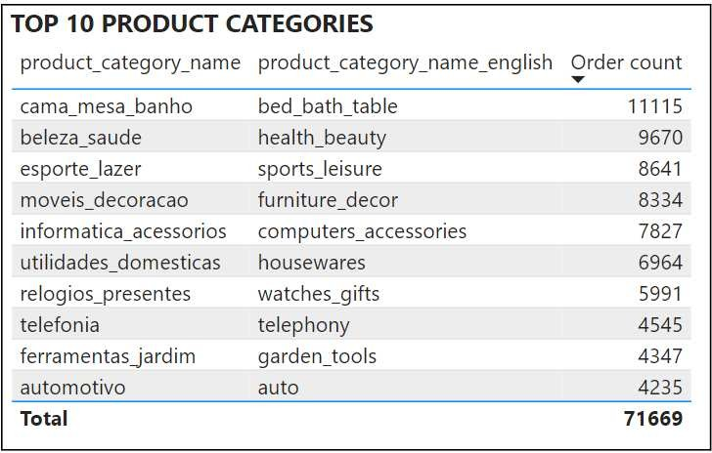

*Table* *2.* *Top* *10* *product* *categories* *table*

* The bottom 18 product categories have significantly lower order counts compared to the top categories, suggesting reduced consumer demand in these segments.
* The least ordered products include "Security and Services," "Fashion - Children's Clothes," and "La Cuisine," with order counts of 2, 8, and 14, respectively. These low numbers may be due to factors such as limited consumer interest or high competition from other products.

*The order volumes for these 18 product categories are significantly low, requiring attention. Enhancing marketing strategies, product quality, and pricing could help boost demand and create opportunities for growth.*

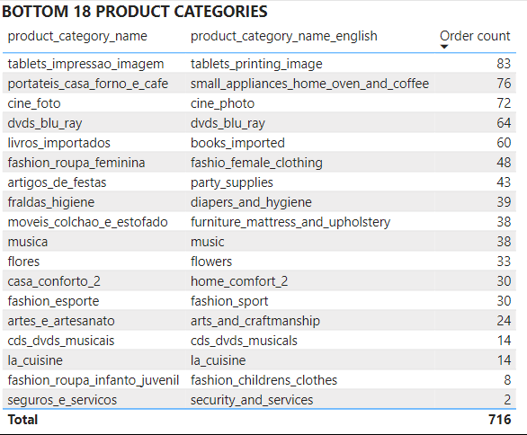

*Table* *3.* *Bottom* *18* *product* *categories* *table*

# TASK – 3

Question Statement:

List the total number of active sellers by yearly and monthly.

Visualization:

The bar chart below depicts the total number of active sellers by month and year. The length of each bar represents the number of sellers active during each specific time period.

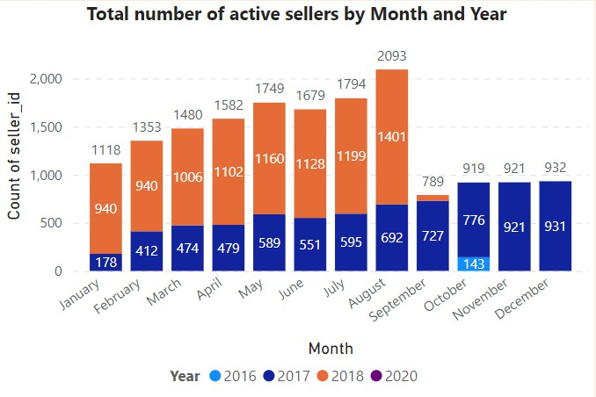

*Image* *4.* *Total* *number* *of* *active* *sellers*

## Explanation:

* The bar chart reveals an upward trend in the number of active sellers over the years, with 2018 having the highest count.
* The number of active sellers steadily increased year-over-year, particularly from 2017 onward. For instance, in July, the seller count grew from 178 in 2017 to 940 in 2018, peaking at 2,093 the same year. This growth reflects a significant expansion in the seller base.
* A clear seasonal pattern emerges, with the number of active sellers peaking during mid-year months (June to August) compared to the beginning and end of the year. This trend may be driven by sales events, holidays, or increased consumer demand during these months.
* The year 2017 stands out with the highest number of active sellers across all months, with significant spikes in July and August.
* In 2018, there was a sharp decline in active sellers after August, dropping from 1,401 to just 62. This significant drop may indicate a major disruption in seller activity.

*Overall, the chart highlights both the growth and decline in active sellers over time, emphasizing the need for greater stability in seller participation.*

# TASK – 4

Question Statement:

Which payment methods are most commonly used by ShopNest customers.

Visualization:

The pie chart below displays the distribution of customers based on their preferred payment methods.

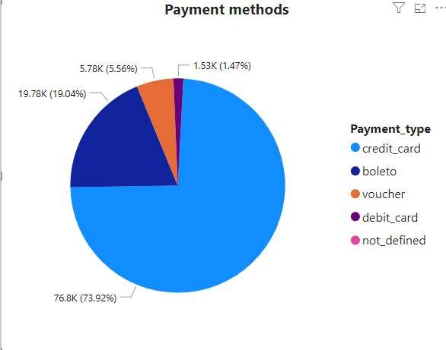

*Image* *5.* *Payment* *methods*

Explanation:

* The pie chart shows that the majority of payments, approximately 73.92%, are made using credit cards. In terms of payment count, credit cards account for 76,795 transactions, followed by boleto (19,784), vouchers (5,775) and debit cards (1,529).
* Customers show a strong preference for credit card transactions due to their convenience, rewards, and widespread acceptance. Boleto, on the other hand, is primarily used for regional payments.
* Some customers opt for vouchers due to promotional offers, while debit card usage remains lower compared to credit cards.

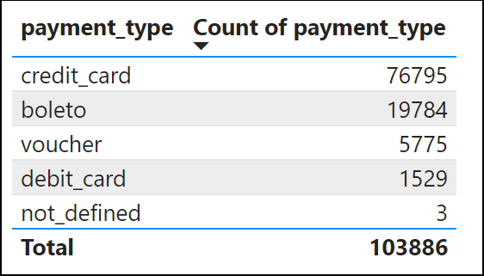

*Table* *4.* *Payment* *type* *with* *counts*

# TASK – 5

Question Statement:

Identify the product category. wise profit margin using the formula

**Hint:** **(Payment** **value** **-price** **+** **Freight_value)/payment_value*100** (Rounded to two decimal points).

Visualization:

The card below illustrates the profit margin.

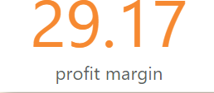

*Image* *6.* *Profit* *margin*

Explanation:

The current profit margin stands at 29.17%, meaning that this percentage is retained as profit. This reflects a healthy profit level.

|  |  |
| --- | --- |
| **product_category_name** | **profit** **margin** |
| agro_industria_e_comercio | 99.58 |
| alimentos | 99.86 |
| alimentos_bebidas | 99.93 |
| artes | 99.87 |
| artes_e_artesanato | 99.99 |
| artigos_de_festas | 99.98 |
| artigos_de_natal | 99.97 |
| audio | 99.72 |
| automotivo | 96.88 |
| bebes | 97.85 |
| bebidas | 99.9 |
| beleza_saude | 93.28 |
| brinquedos | 97.46 |
| cama_mesa_banho | 94.8 |
| casa_conforto | 99.69 |
| casa_conforto_2 | 100 |
| casa_construcao | 99.57 |
| cds_dvds_musicais | 100 |

|  |  |
| --- | --- |
| cine_foto | 99.96 |
| climatizacao | 99.7 |
| consoles_games | 99.14 |
| construcao_ferramentas_construcao | 99.23 |
| construcao_ferramentas_ferramentas | 99.91 |
| construcao_ferramentas_iluminacao | 99.79 |
| construcao_ferramentas_jardim | 99.87 |
| construcao_ferramentas_seguranca | 99.77 |
| cool_stuff | 96.56 |
| dvds_blu_ray | 99.97 |
| eletrodomesticos | 99.59 |
| eletrodomesticos_2 | 99.36 |
| eletronicos | 99.29 |
| eletroportateis | 98.91 |
| esporte_lazer | 94.88 |
| fashion_bolsas_e_acessorios | 99.24 |
| fashion_calcados | 99.88 |
| fashion_esporte | 99.99 |
| fashion_roupa_feminina | 99.99 |
| fashion_roupa_infanto_juvenil | 100 |
| fashion_roupa_masculina | 99.95 |
| fashion_underwear_e_moda_praia | 99.95 |
| ferramentas_jardim | 97.59 |
| flores | 100 |
| fraldas_higiene | 99.99 |
| industria_comercio_e_negocios | 99.8 |
| informatica_acessorios | 95.22 |
| instrumentos_musicais | 98.92 |
| la_cuisine | 99.99 |
| livros_importados | 99.98 |
| livros_interesse_geral | 99.76 |
| livros_tecnicos | 99.91 |
| malas_acessorios | 99.31 |
| market_place | 99.86 |
| moveis_colchao_e_estofado | 99.98 |
| moveis_cozinha_area_de_servico_jantar_e_jardim | 99.79 |
| moveis_decoracao | 96.52 |
| moveis_escritorio | 98.72 |
| moveis_quarto | 99.9 |
| moveis_sala | 99.68 |
| musica | 99.97 |
| papelaria | 98.85 |
| pc_gamer | 99.99 |
| pcs | 98.67 |
| perfumaria | 97.85 |
| pet_shop | 98.91 |
| portateis_casa_forno_e_cafe | 99.72 |
| portateis_cozinha_e_preparadores_de_alimentos | 99.98 |
| relogios_presentes | 93.1 |

|  |  |
| --- | --- |
| seguros_e_servicos | 100 |
| sinalizacao_e_seguranca | 99.91 |
| tablets_impressao_imagem | 99.96 |
| telefonia | 98.42 |
| telefonia_fixa | 99.66 |
| utilidades_domesticas | 96.96 |

*Table* *5.* *Profit* *margin* *for* *product* *categories.*

# TASK – 6

Question Statement:

Determine the monthly payments made by customers using credit cards.

Visualization:

The bar chart below depicts the total number of credit card payments per month, with the length of each bar representing the payment volume.

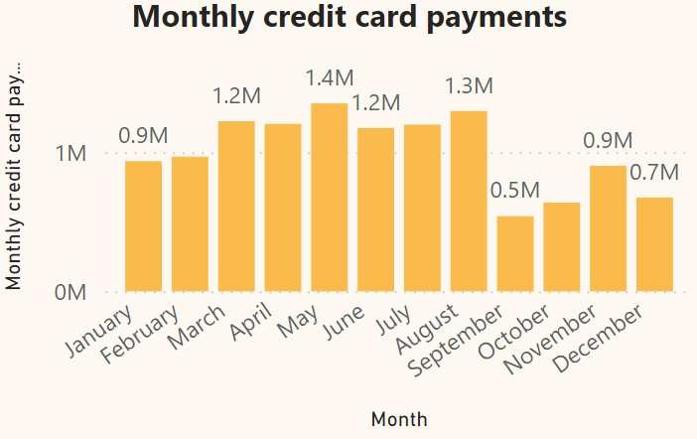

*Image* *7.* *Monthly* *credit* *card* *payments*

Explanation:

* The monthly credit card payments data shows that the highest payment volumes occurred in May and August, with approximately 1,350,470 and 1,295,705 transactions, respectively.
* The lowest payment volumes were recorded in September (539,830) and October (637,113).
* Payments are significantly higher during the mid-year months (April to August) compared to the beginning (January, February) and end (November, December) of the year, suggesting seasonal buying patterns during peak months.
* Payments dip significantly in September and October. This could be due to holiday period.

|  |  |
| --- | --- |
| **Month** | **Monthly** **credit** **card** **payments** |
| January | 935,503.13 |
| February | 967,806.12 |
| March | 1,222,595.64 |
| April | 1,203,243.52 |
| May | 1,350,469.09 |
| June | 1,173,689.71 |
| July | 1,198,037.96 |
| August | 1,295,705.69 |
| September | 539,830.37 |
| October | 637,113.55 |
| November | 902,370.15 |
| December | 674,259.87 |

*Table* *6.* *Monthly* *credit* *card* *payments*

# TASK – 7

Question Statement:

Identify sellers categorized by city, excluding cities starting with the letters S and B.

Visualization:

The table below displays the number of sellers in each city, excluding those with names starting with the letters 'S' and ‘B’.

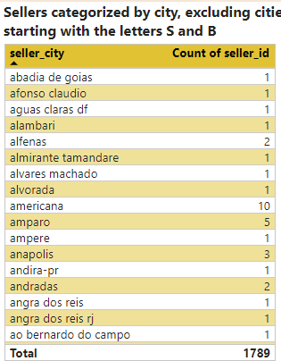

*Image* *8.* *Sellers* *categorized* *by* *city*

Explanation:

The top 10 cities with the highest seller counts are listed.

Curitiba and Rio de Janeiro have the most sellers, with 127 and 96, respectively.

|  |  |
| --- | --- |
| **seller_city** **Count** **of** **seller_id** | |
| curitiba | 127 |
| rio de janeiro | 96 |
| ribeirao preto | 52 |
| guarulhos | 50 |
| ibitinga | 49 |
| campinas | 41 |
| maringa | 40 |
| osasco | 32 |
| porto alegre | 28 |
| londrina | 26 |

# TASK – 8

Question Statement:

Create a dynamic visual that compares the number of delayed orders to the number of orders received earlier for each month. Utilize the drill through the cross-report feature to provide a detailed analysis of late and on-time deliveries.

Visualization:

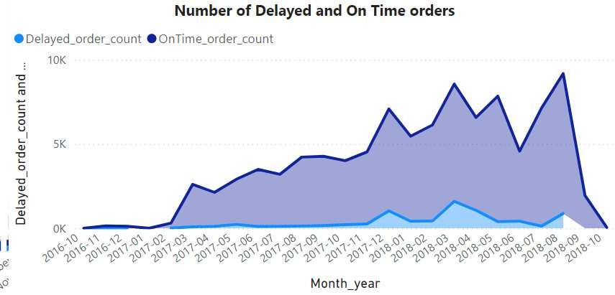

*Image* *9.* *Number* *of* *delayed* *and* *on* *time* *orders.*

Explanation:

* There is a notable rise in delayed orders from January 2017 to October 2018. This increase calls for an investigation into potential causes, such as supply chain disruptions, logistical challenges, or shifts in order volume.
* There is substantial increase in on time delivery of orders indicating the logistics partners are efficient.